

SenzoUnit

Hardware User Guide

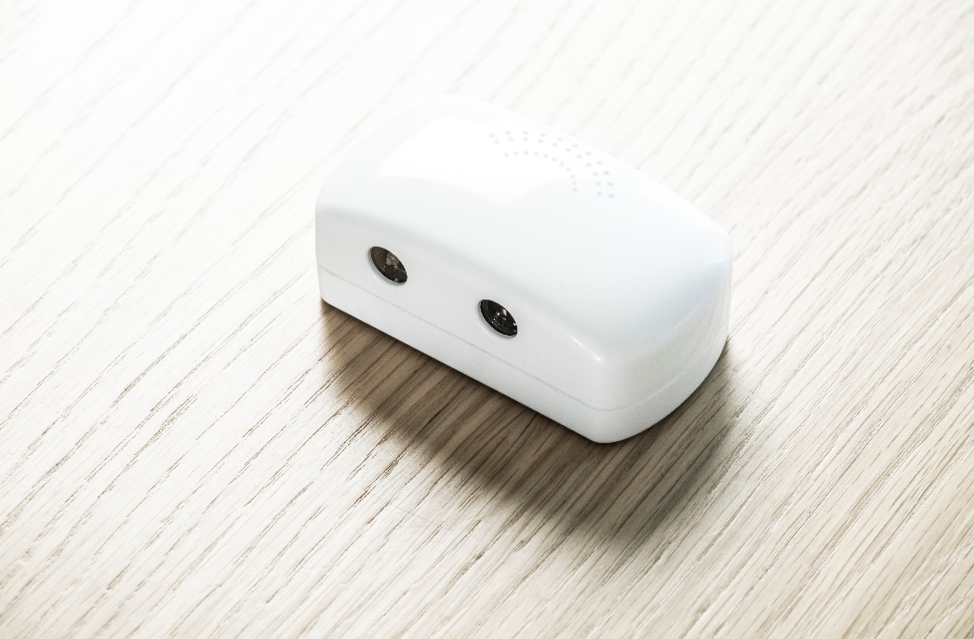

# Overview of the SenzoUnit

Figure 1 – Back panel

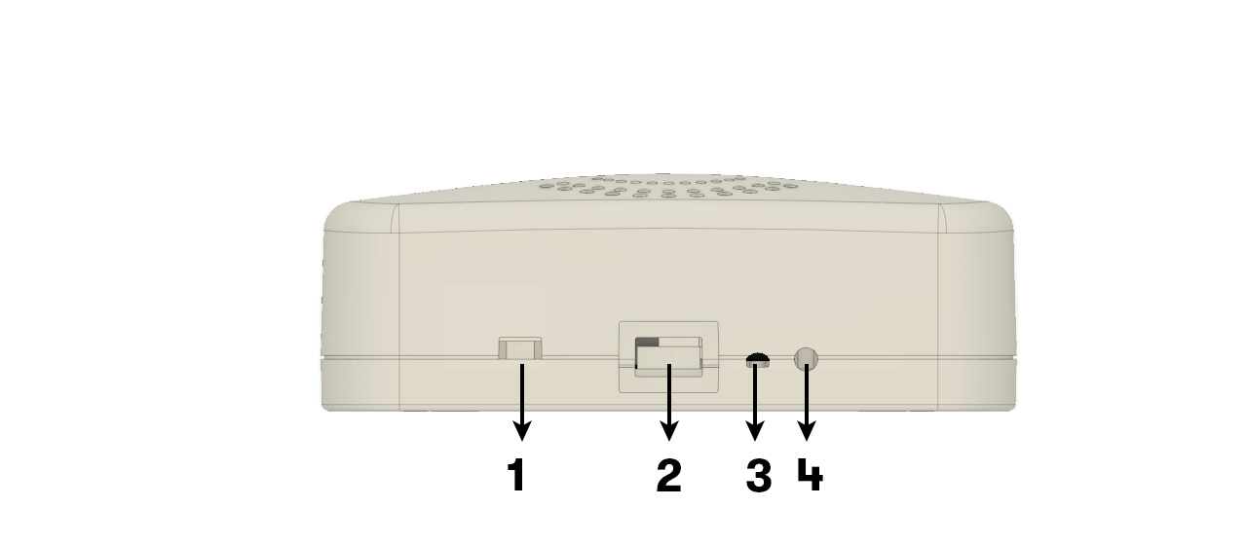

|  |  |
| --- | --- |
| 1 | Power Switch (default ON) |
| 2 | Micro USB Input |
| 3 | RGB LED |
| 4 | Reset button |

## Accessories

The SenzoUnit comes with:

* Hardware User Guide
* Zip tie and self-adhesive anchor
* Micro USB Cable
* Multi-port Power hub & 5V / 1A USB Wall charger (Plug type depends on region)

# Installation

This chapter shows how to connect and install the SenzoUnit.

## Tools and Materials

* 1 x Laptop with Internet access
* 1 x USB Optical barcode scanner
* Wire cutter
* Micro USB Cable
* Zip tie and self-adhesive anchor
* (Optional) 1 x Power socket
* (Optional) 3G/4G Wi-Fi Router

Note: In one-seat location, a 5V / 1A USB Wall charger is needed to power the SenzoUnit.

While in Open area / Meeting room, a Multi-port Power hub is preferred.

## Network

A pre-configured Access Point (AP) is required and it can be either provided by the customer (existing network) or by SenzoLive (Model: Ruckus M510). The network information (SSID and Password) can be shared to SenzoLive in order to configure the SenzoUnits on-site.

SenzoUnit works only with 2.4GHz band Wi-Fi

## Overview of Installation

This part is applicable for both Demo or small team installation. The duration for each sensor should not exceed 2 minute per desk and the steps have been calculated to achieve a quick and reliable process.

### Step 1 – Scan & add the SenzoUnit to platform

Using the provided account to access <https://software.senzolive.com/>, choose the installation area from Homepage and press “Live” .

To start adding sensors, choose the  icon on the top right corner, it will generate a “node” which equivalent to a sensor.

Select the location of the sensor and left-click directly on the floor plan. A pop-up window will appear prompting for sensor’s information.

Connect the USB Optical barcode scanner to laptop and scan the MAC address label of the sensor. Once scanned, the value will appear on the field. (see Figure 2).

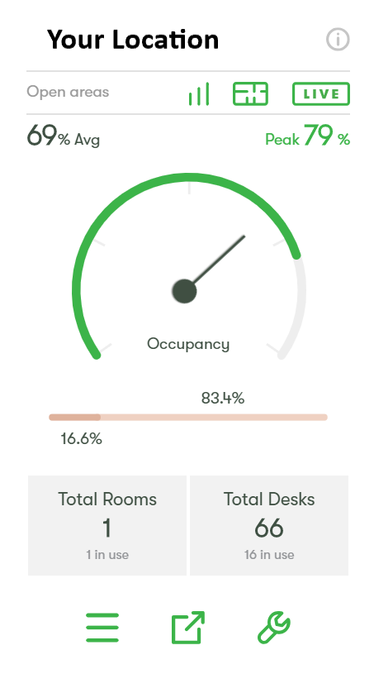

Figure 2 - Add Sensor

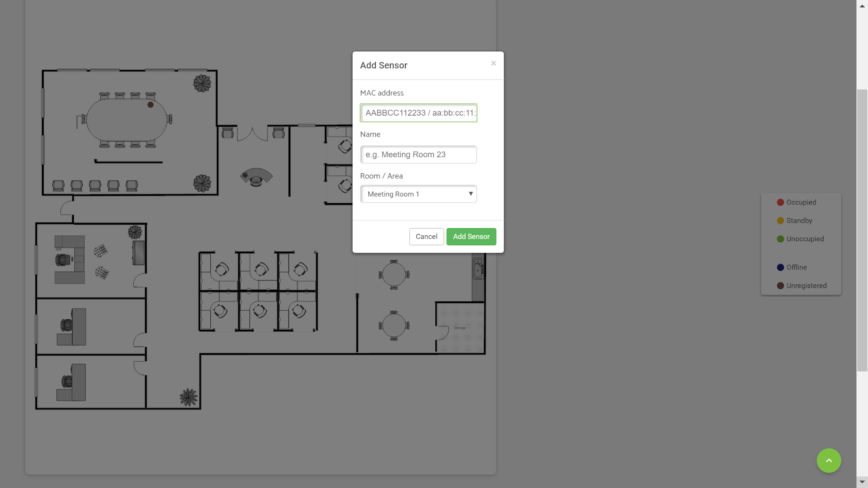

### Step 2 – Locate the suitable position

The acceptable distance from the front to SenzoUnit is in 10 – 40 cm (4 – 15 in) range. Ideally, 20 cm (8 in) results in the most reliable data reading. SenzoUnit’s front should be clear from obstacles and be placed parallel with the desk.

Figure 3 – Location

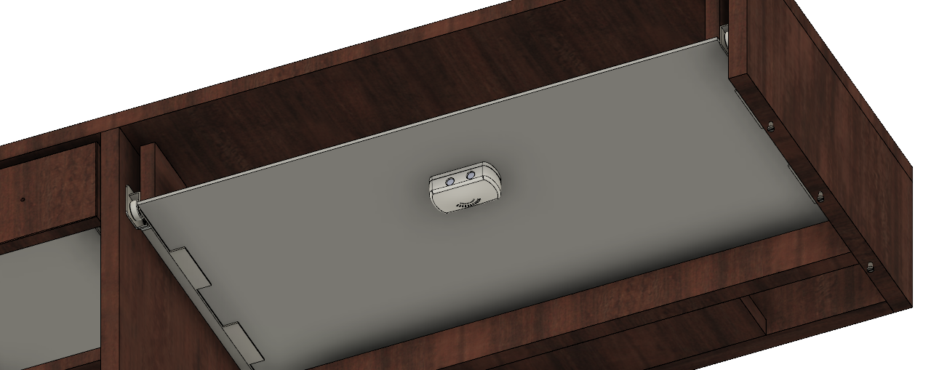

### Step 3 – Mount and secure the SenzoUnit

To install

1. Apply firm pressure to the SenzoUnit with RP45 taped underneath to desired position.
2. Attach Micro USB cable to the SenzoUnit and secure with zip tie and anchor provided.

Figure 4 – Mounting

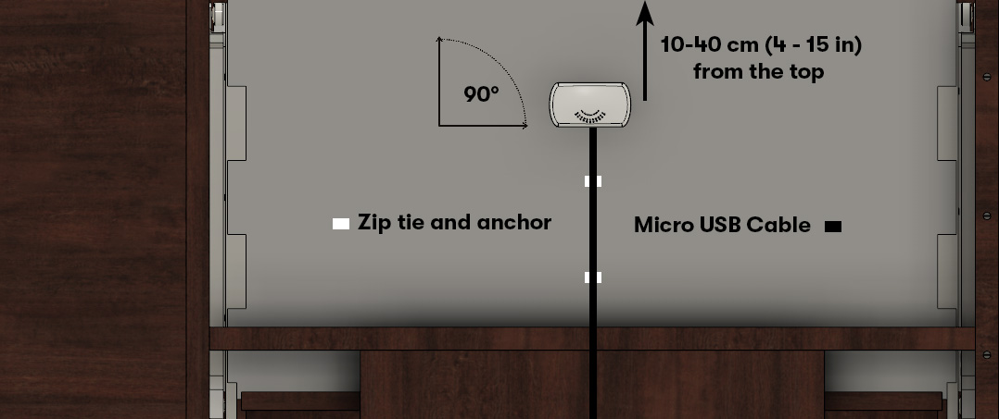

### Step 4 – Connect the power

Using the available power socket to install the Wall charger or Power hub. The provided Micro USB cable is either in 2m or 3m (6.5 or 10 ft.) depends on the distance from SenzoUnit to power source. Measuring the length from SenzoUnit to power source before choosing the cable. Remember to leave a few centimetres loose cables unzipped to avoid constrain and stretch.

Multi-port Power hub can power up to 10 SenzoUnit simultaneously. Mounting all the SenzoUnit securely before plugging in the USB-port.

See Appendix 1 for an example of a completed installation.

# Large Installations

This part is applicable for high quantity projects utilising a 4-man team.

## Tools and Materials

Addition to the basic tools listed above:

* 1 x Laptop with Internet access
* 1 x USB Optical barcode scanner
* (Optional) Spare Android/iPhone device for resetting SenzoUnit

### Step 0 – Dividing the task

The task is divided for 2 teams:

* Team A (2 members): Scanning and adding SenzoUnit to SenzoLive
* Team B (2 members): Installing the SenzoUnit

### Team A – Scanning and adding the SenzoUnit to SenzoLive

Follow step 1 from “Overview of Installation” to scan and add the SenzoUnit onto the platform. Once it is done, follow steps 2 & 3 from to place the unit.

### Team B – Installing the SenzoUnit

Follow step 4 from “Overview of Installation” to connect power source for the SenzoUnits.

Step 2 – Maintenance Review

At the end of the installation, open SenzoLive Software, click on the live floor layout, and click on

Maintenance view and address all Blue and brown spots.

Brown dots indicate SenzoUnit that have not connected to the site at any time – check power or correct the MAC address.

Blue dots indicate that SenzoUnit have connected but are now offline, this may be Wi-Fi coverage and the router needs to be moved to a more central location or the power may have

been disconnected.

Figure 5 – Maintenance View



## Troubleshooting

Resetting the SenzoUnit is done when the sensor is unresponsive. It is done using an iOS or Android mobile device.

Soft Reset SenzoUnit: press and hold the configuration button with a paper clip for 10 seconds until the LED blinks green. Then turn the power off and on.

Hard Reset SenzoUnit: by pressing the configuration button with a paper clip for 10 seconds until the LED blinks green.

1. While sensor is in configuration mode, it will show a Wi-Fi network named “**SenzoLive-MAC Address**” on the mobile device.
2. Connect to the network and password is always “**senzo**”. (Android devices from version 6 will display a message ‘This network has no internet access, stay connected?’ Always select ‘Yes’)
3. After connecting to the SenzoUnit, the LED will blink green rapidly. Open Safari, Chrome or Firefox internet browser and type the following address [**http://192.168.0.1**](http://192.168.0.1)
4. The following configuration screen appears, insert the new network information (SSID and Password) if required. Server address, port and passphrase are automatically filled.
5. After “Save”, the LED switches off and a following line is shown on the website: “**Configuration saved, resuming operative mode”** indicates completed process.

# Appendix

## Appendix 1 – A sample of completed installation

